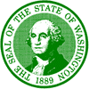

State of Washington
DEPARTMENT OF FISH AND WILDLIFE

Mailing Address: 600 Capitol Way N • Olympia, WA 98501-1091 • (360) 902-2200, TDD (360) 902-2207
Main Office Location: Natural Resources Building • 1111 Washington Street SE • Olympia, WA

Date: | 3 December 2018
To: | Operations Project Manager  U.S. Army Corps of Engineers  Bonneville Lock and Dam  P.O. Box 150  Cascade Locks, OR 97014
From: | Steven Jeffries, Washington Department of Fish and Wildlife  Sheanna Steingass, Oregon Department of Fish and Wildlife  Christine Kozfkay, Idaho Department of Fish and Game  Doug Hatch, Columbia River Intertribal Fish Commission
Subject: | Research Packet – Project Impacts Document

Enclosed is our request to conduct sea lion capture, marking, tracking, hazing, and removal operations in the Boat Restricted Zone at Bonneville Dam in 2019.

The work we are proposing for 2019 has not changed significantly from that conducted in recent years. Our Bonneville Project contact for this work is Ben Hausmann. Please contact Ben or myself if you have questions or need additional information on our work. Thank you for your assistance.

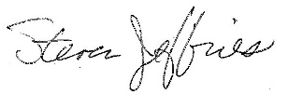

Steven Jeffries
Washington Department of Fish and Wildlife
Marine Mammal Investigations
Steven.Jeffries@dfw.wa.gov
(253) 380-4963

